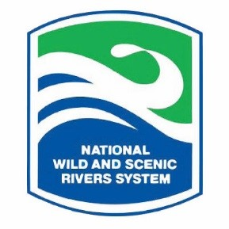
Lower Delaware Wild & Scenic River Management Council Meeting: Thursday, Sept. 24, 2020
www.lowerdelawarewildandscenic.org

The meeting was called to order at 10:00 AM by Steering Committee Chair, Richard Dodds. The meeting was held virtually via Zoom. There were approximately 40 attendees, including 5 members of the Steering Committee, one Delaware River Greenway Partnership staff member, and a National Park Service (NPS) staff member.

Council Business:

- Approval of Minutes: A motion was made by Norm Torkelson, seconded by Martie Kyde, to accept the June 25, 2020 meeting minutes, previously posted at www.lowerdelawarewildandscenic.org. Passed.
- Acceptance of New Steering Committee Member: Evan Kwityn with the Delaware River Basin Commission: Martie Kyde made a motion, seconded by CC Hopf, to accept Evan as a new Steering Committee member. Passed.
- River Use This Year and Concerns of Governmental Entities: Chairman Dodds facilitated a discussion about the high recreational use of the river this year due to the pandemic. Trash, human waste, parking, traffic, and public safety issues were faced throughout the corridor. Mr. Dodds said the Council is undertaking a recreational river use study starting with a public questionnaire and a town hall.
- Keynote Speaker: Risa Shimoda, Lower Delaware Wild & Scenic River Use Capacity Study Consultant: Ms. Shimoda discussed, “Undertaking Lower Delaware’s Study: What are we looking at? What will the study do?”
Representatives of park systems, counties, nonprofits, and local municipalities shared observations/concerns.
- Ongoing Environmental/Land Use Matters Being Tracked: Updates were provided on the following matters: NJDEP Devil’s Tea Table Rockfall Mitigation Along Route 29 (Kingwood Twp, NJ); I80 Rockfall Project Public Advisory Group: Lower Delaware Participation (Knowlton Twp, NJ); Warehouse Development Proposal (White Township, NJ); Anticipated Warehouse Development (Upper Mount Bethel, PA); Pollution Control Plan & Stormwater Plan: Lower Delaware Comment Letters (Bedminster, PA); PennEast Pipeline: Lower Delaware Comment Letter Opposing Proposed Environmental Assessment Process; Headquarters Bridge (Tinicum Twp, PA) – NPS Hydrology Review; and a Proposed Cell Tower Along Delaware (New Holland Twp/Riegelsville, NJ). Questions and comments were shared by the meeting participants.
- New Business/Municipal Announcements: There was no new business or announcements.

Conclusion:

- Next Meetings & Adjournment: The next virtual meeting is scheduled for Thursday, December 3, 2020 at 10:00 AM. With no new business, meeting adjourned at 11:44 AM.

